

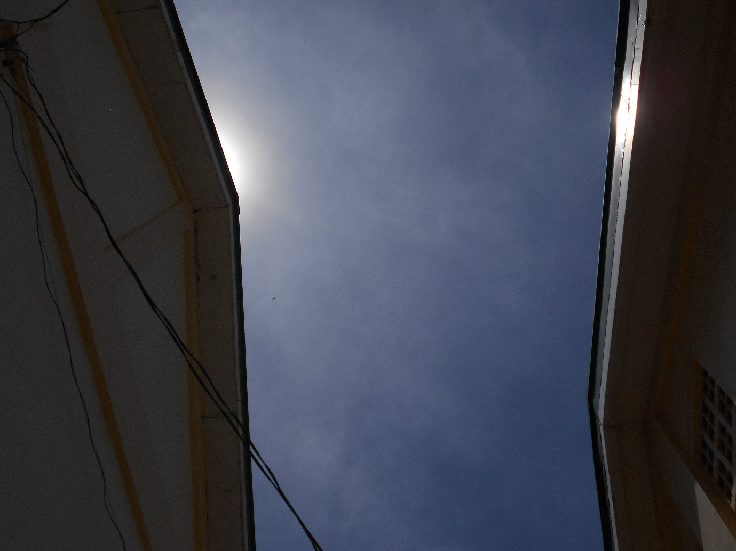

***Hot Spot.*** The sun emphasizes the captivating school architecture, during the late morning hours of Dapitan City National Highschool.

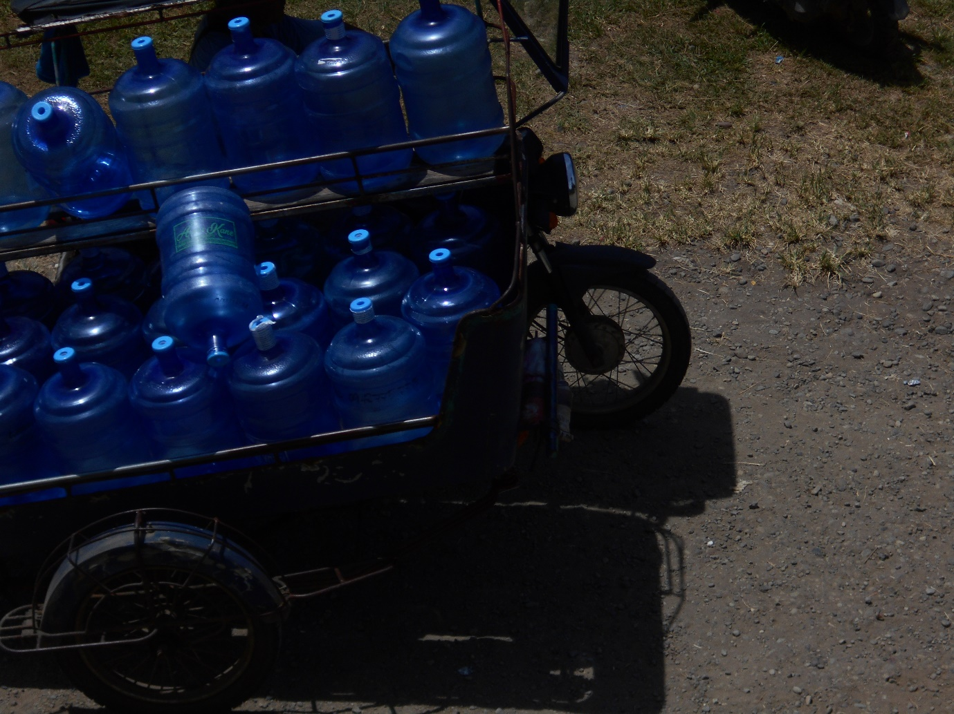

***Hotter, More Water***. As the temperature rises, water delivery rushes in the high demands of mineral consumers in Dapitan City this morning.

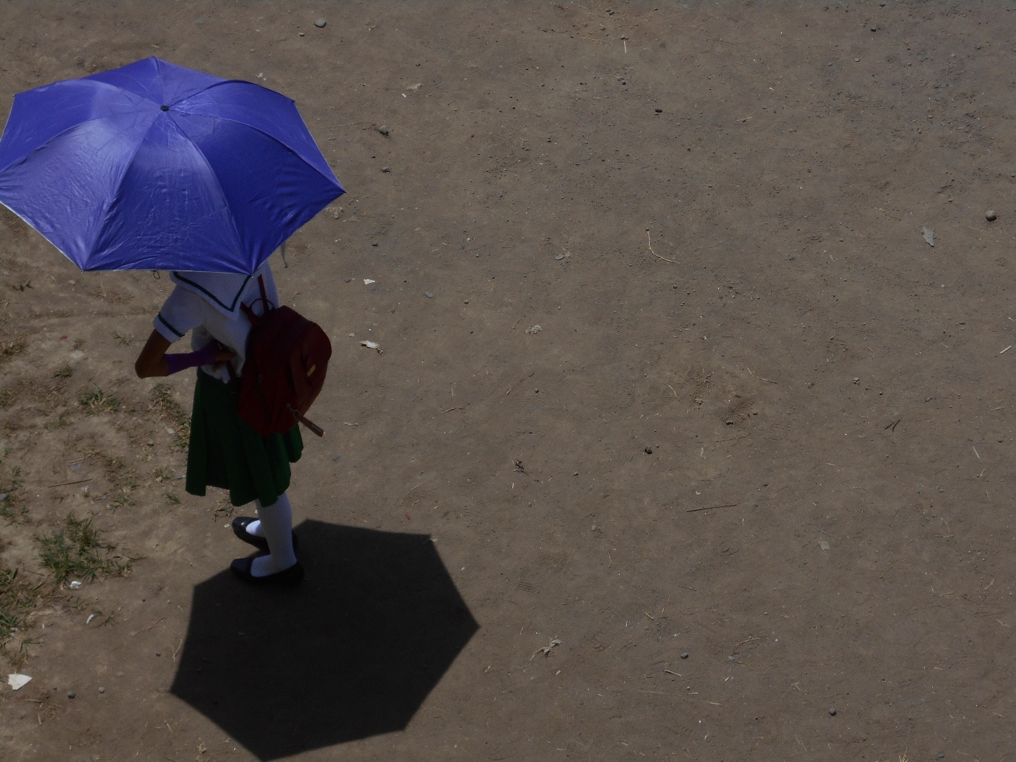

***You Can’t Stand Under My Umbrella.*** A school girl irritatingly waits for her friends on the campus grounds, under the scorching heat of the afternoon sun.



***Beat The Heat***. The scorching weather did not let an old man stop him from going to work as a construction worker just to feed his children, spotted earlier this afternoon behind the school gate of Dapitan City National High School.



***Sun Ain’t Fun No More, But Class Still Is***. Earlier this afternoon, students in Dapitan City National High School proceed to achieve their academic goals, despite suffering under the extreme heat of the sun.